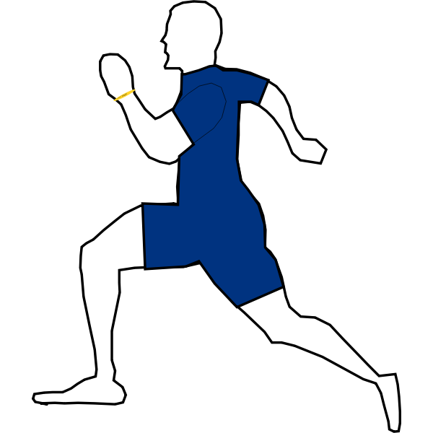
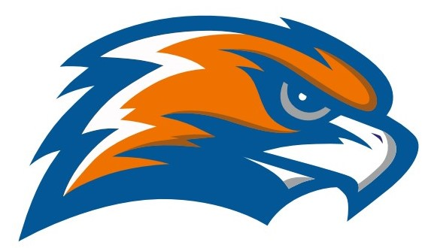
GARRETT MORGAN Cross-Country 2021
Boys’ Head Coach Kelly O’Connor Girls’ Head Coach Ron Schroth Jr.
Athletic Director Jennifer Smith
Principal GMSEI Quenton Davis
Principal GMSLI Anshawn Ivery – Administrator for Athletics

DATE | TIME | LOCATION | Who runs first
Wednesday  8/25 | 3:30 | Luke Easter Park | Girls
Wednesday  9/1 | 3:30 | Edge Water | Boys
Wednesday  9/8 | 3:30 | BrooksidePark | Girls
Wednesday  9/15 | 3:30 | Luke Easter Park | Boys
Monday  9/20 | 3:30 | Brookside Park | Girls
Wednesday  9/29 | 3:30 | Luke Easter Park | Boys
Wednesday  10/6 | 3:30 | Wallace Lake | Girls
Inclement Weather Dates: September 13 & October 11 @ Luke Easter Park
SENATE CHAMPIONSHIP - Wednesday October 13
Wallace Lake 4:00 pm
Inclement Weather Date - Monday October 25

OHSAA District Meet - October 23

Senate Athletic League
Bard John Adams Campus International John Hay Collinwood John F. Kennedy East Tech John Marshall Garrett Morgan Lincoln-West Glenville Max S. Hayes
James F. Rhodes

